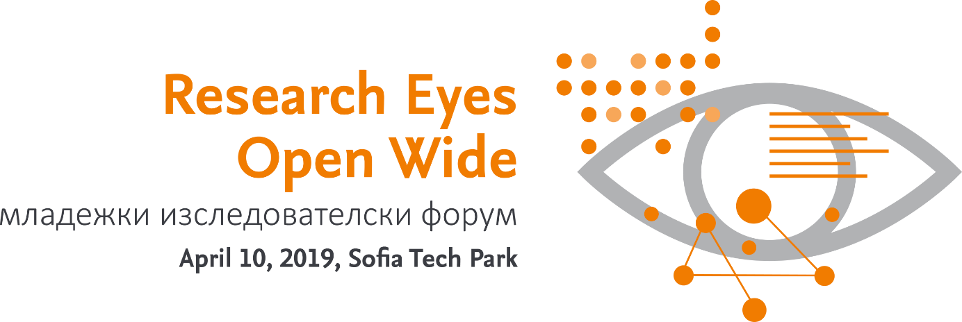
Subject: Research Eyes Open Wide: младежки изследователски форум 10.4.2019 Регистрация

Dear xxx,
We would like to invite you to attend a special event organized on April 10th 2019 in cooperation of Ministry of Education and Science of Bulgaria and Elsevier:
Research Eyes Open Wide: младежки изследователски форум
It is important for young researcher today to acquire many skills that are not directly part of their education. Science Eyes Open Wide – young researcher Forum aims to provide a platform to share experiences among young researchers and give the opportunity to acquire knowledge in areas of scholarly publishing, recognition and visibility of own work, measuring research. At this occasion, Ministry will share plan of support and development of research in Bulgaria with a focus on young researchers. Focus will be given to all research areas including arts and humanities.
Meet your peers, listen to experiences of successful young researchers, learn needed skills and understand what it is and will be a young researcher in Bulgaria!
Interested?

*Participation is free of charge
Venue:
София, Sofia Tech Park, бул. Цариградско шосе, N 111,
Лабораторен комплекс, зала ет.1 (до етажния паркинг)

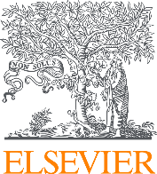

Programme:
9:00 – 9:20 | Deputy minister address to young researchers, Mrs Karina Angelieva- Deputy Minister of Education and Science, Ministry of Education and Science of Bulgaria
9:20 – 9:40 | Experiences of successful young researcher
9:40 – 10:00 | Closer look on Bulgarian research – insights and perspectives,  Shadi Awwad, Senior Research Solutions Manager, Elsevier
10:00 – 10:30 | Coffee break
10:30 – 12:30 | Good practices in scholarly publishing: how to get published and gain recognition?
12:30 – 13:15 | Sandwich lunch
13:15 – 15:00 | Get your facts first: Research assessment without secrets  Peter Porosz, Research Solutions Manager, Elsevier  Enhancing the Visibility and Discoverability across all research areas  Shadi Awwad, Senior Research Solutions Manager, Elsevier
Get your facts first: Research assessment without secrets, Peter Porosz, Research Solutions Manager, Elsevier
Enhancing the Visibility and Discoverability across all research areas, Shadi Awwad, Senior Research Solutions Manager, Elsevier
We hope to see you at this must attend event!
Kind regards,
Organization team

